**WEEK 4**

1.Create a keyspace by name Employee

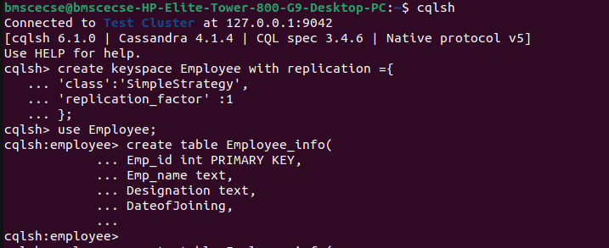

2. Create a column family by name

Employee-Info with attributes

Emp_Id Primary Key, Emp_Name,

Designation, Date_of_Joining, Salary,

Dept_Name



3. Insert the values into the table in batch

4. Update Employee name and Department of

Emp-Id 121

